Perform an ALT-1 IML of the controller:-
- Press and hold the Alt 1 push button on the operator panel.
- While holding the Alt 1 push button, press and release the IML push button.
- When you see 31 in the status indicators, release the Alt 1 push button. If 31 does not appear, refer to 3174 Status Codes.
- Now 40 appears in the status indicators. Use the keypad on the controller operator's panel to key in one of the following codes:-

  - 0140 if you are IMLing from Diskette Drive 1
  - 0240 if you are IMLing from Diskette Drive 2
  - 0340 if you are IMLing from Fixed Disk 3
  - 0440 if you are IMLing from Fixed Disk 4
The “Customize Control Disk” menu appears.
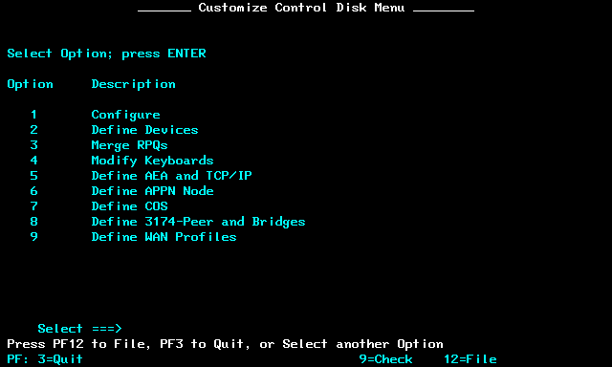
Menu 1 configures the basic settings.

This is the first config screen.
- I set the host attachment to SDLC as this keeps all the LAN setting separate. You may have to use one of the other options, depending on model. Avoid “7” or “8” if possible.
- The “LAN Adapter Type” should match your network card. I have Token Ring
- NSO == None Standard Options. Set to Zero.

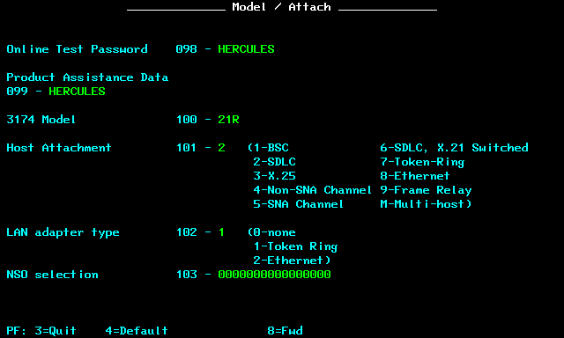
Hit “PF8”to get to the LAN screen. Mine comes up as “Token Ring”. Set as needed.
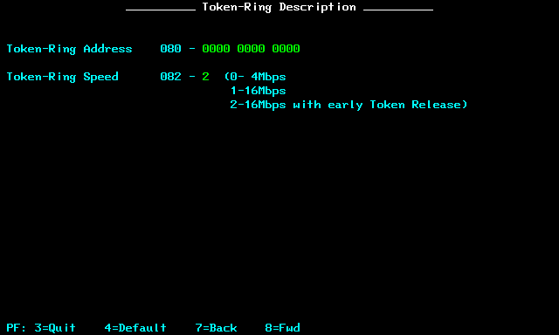

Hit PF8 to get to the “SDLC” screen. if you specified a different connection type you will get a different screen.
- Q106 reserves memory for multiple sessions
- Q116 is significant here. “S4” says four sessions per port
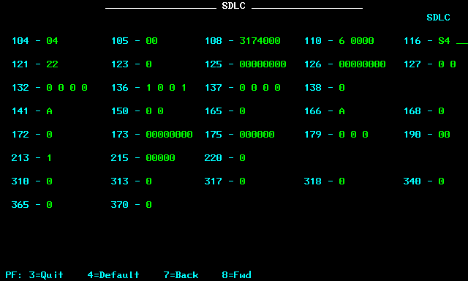
I then got “common SNA” as I choose SDLC which I left at the default values.
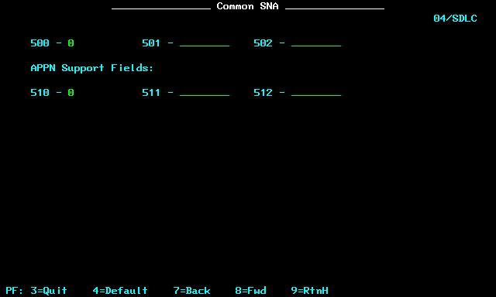

Hitting PF8 takes me to this field. As I specified “S4” I get four addresses per port.
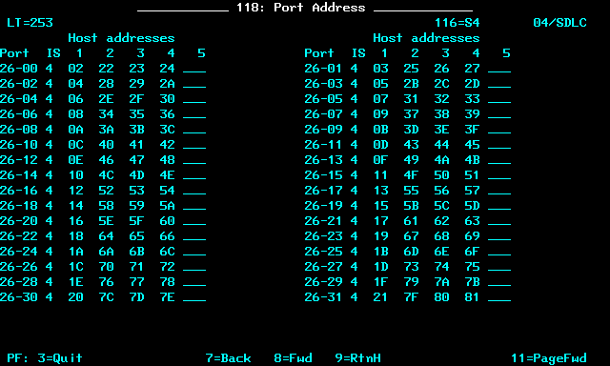
I defined the calculator more for fun than anything else.
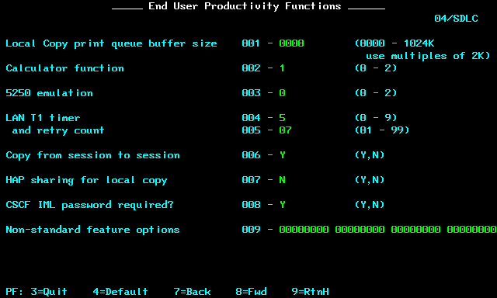
At this point PF8 takes me back to the main menu.

Now it is time to configure the TCP/IP and TN3270 stuff. Hit “5” on the main menu.
- Q700 defines ASCII terminal attachment (AEA) and TCPIP.
  - Set the first digit to “1” enables ASCII devices on real serial ports (e.g. VT100)
  - Set the second digit to “1” to enable TCPIP, or “2” to enable TCPIP with SNMP
- The other options relate to AEA not TCP/IP
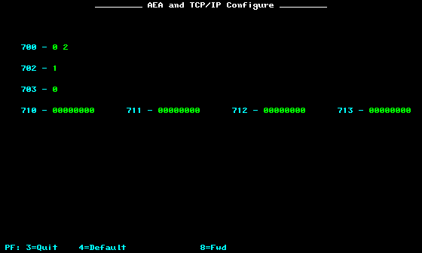
The next screen defines “Port Sets” which allows multiple screens to have the terminals to have the same configuration. As I only have one 3270 I defined one Port Set of type “3270”
- The session limit says how many sessions.
- The port type here is “1” as these are referring to a 3270 CO-AX terminal, not an ASCII terminal or Printer.

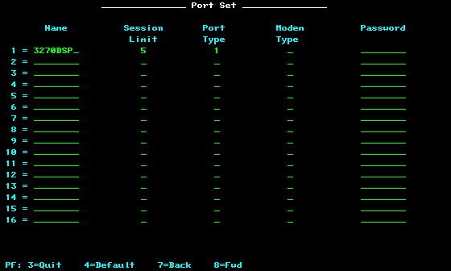

This screen maps “Port Sets” from above to the actual sockets on the 3174.
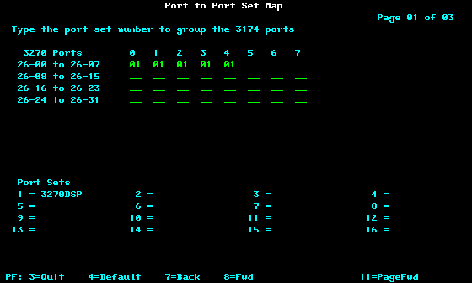
The next two screens define the station sets. On the first two:-
- “722” set to “TH” so are Telnet sessions.
- “751” is set to “1” so they are VT100 sessions
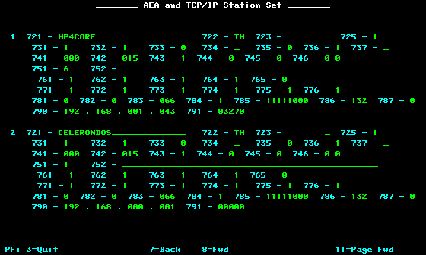

- On the third
  - 722 is set to “3D” so these are the actual terminals
  - 725 is “1” so users can choose the destination.
  - 723 matches the Port Set defined above.
- On the fourth “722” is set to TH so terminals and 751 is “6” so a 3270 host.
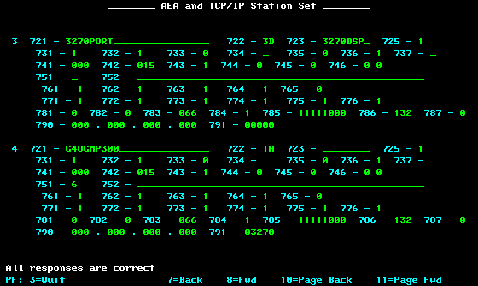
Now we set the default destinations.
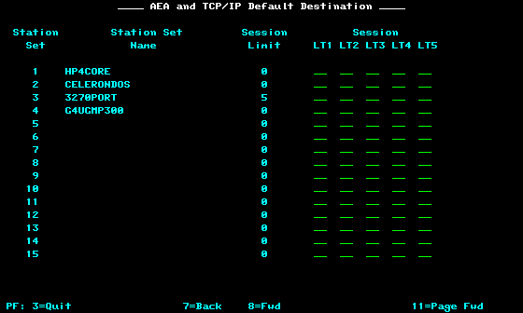

After saving the config and re-booting you should see something like this:-

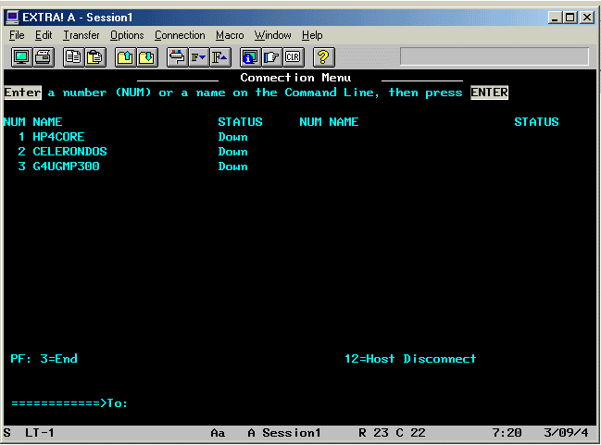
And on to the TCP/IP routing.
- If you have an Ethernet interface this won’t be used.
- If you have Token Ring and have a token ring cardin the host running hercules
- If you have a gateway from Token Ring to Hercules this must be the address of the Token Ring gateway
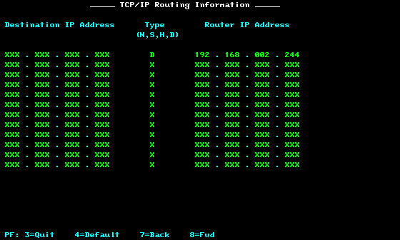
This is your DNS config.
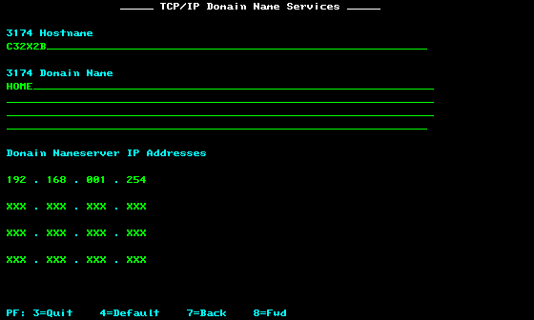

This is a local hosts file….
